The Respiratory System

- Use the diagram on page 89 to label the diagram of the respiratory system below.
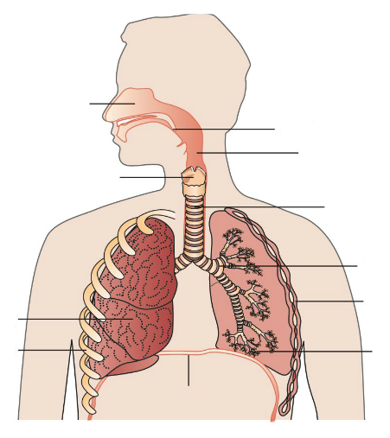

- Explain the function of the following parts of the respiratory system.
  - Nasal cavity

  - Trachea (windpipe)

  - Epiglottis

  - Alveoli

- Gases are exchanged in the alveoli (singular: alveolus). There are around 500 million alveoli in the lungs, giving a total surface area of about 80 square metres.
  - Describe the structure of an alveolus.

  - What are capillaries?

  - Gasses pass from the alveoli to the capillaries by diffusion. Diffusion occurs when substances move from an area of high concentration to areas of low concentration. Explain how this process happens in the alveoli.
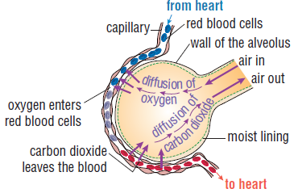

- The intercostal muscles and diaphragm work together when you inhale and exhale to draw air in and then push it out.
  - Describe what happens when you breathe in.

  - Describe what happens when you breathe out.



